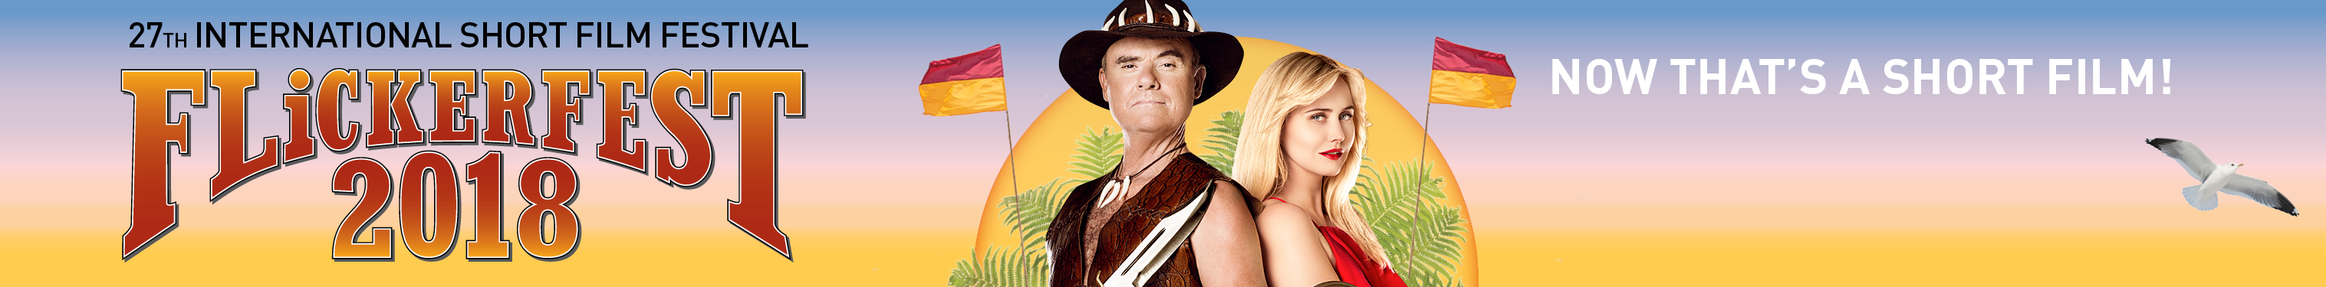
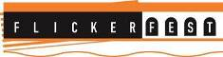
FLiCKERFEST 2018
27th INTERNATIONAL SHORT FILM FESTIVAL
Festival: 12th - 21st January 2018, Bondi Beach, Sydney, Australia
Tour: January - May 2018, 50+ venues Australia-wide
------------------------------------------------------------------------------------------------------------

Flickerfest 2018 - National Tour Press (examples)

2018 tagline:
‘Flickerfest - Now That’s A Short Film!’

Long blurb (edit accordingly):

Celebrating 27 years, Flickerfest is Australia’s leading Academy® Award accredited and BAFTA-recognised Short Film Festival, the country’s largest Australian & International short film competition, screening the best of shorts from Australia and around the world, hand-picked from 2,500 entries.

Flickerfest screens for 10 days under the summer stars at Bondi Beach in January 2018, with selected highlights touring Australia on a 50+ venue national tour from Jan - May 2018. Flickerfest remains a platform for celebrating the most entertaining and innovative short filmmaking from Australia and around the world.

Flickerfest returns to the XXXX with the Best Of Australian Shorts & the Best Of International Shorts, curated from the Flickerfest Australian & International programmes in competition at Bondi; & Short Laughs Comedy a hilarious off-kilter selection of funny shorts from across the world. This is a one-off chance to see these amazing short films before they continue their journey around the world; expect to experience the best in short filmmaking Australia & the world has on offer.

___________

Short blurb (edit accordingly):

Flickerfest Australia’s leading Academy® Award accredited and BAFTA-recognised Short Film Festival returns to the XXXX with the Best Of Australian Shorts, Best Of International Shorts & Short Laughs Comedy programmes. This is a one-off chance to see these amazing short films before they continue their journey around the world; expect to experience the best in short filmmaking Australia & the world] has on offer.

_________________________

